## Written Analysis

## Scores by School Spending

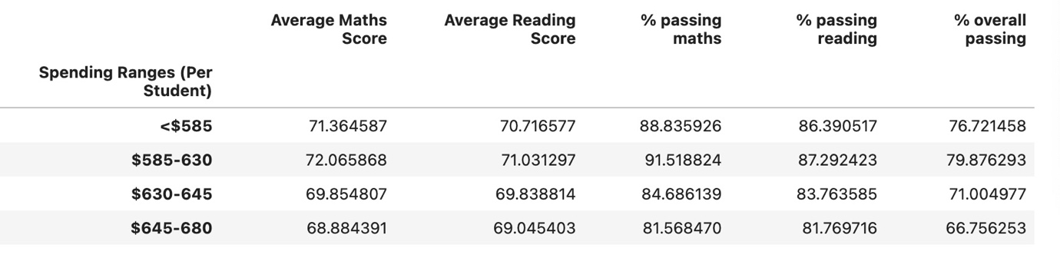

From the spending ranges, students have the highest performance when %585-630 spent per student. Overpending does not lead to greater performance and the budget should be controlled within the range to achieve optimal productivity.

**Scores by School Size**

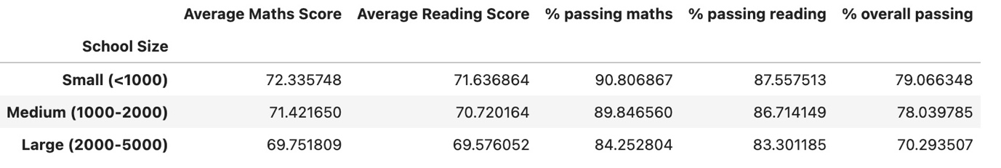

The larger the school size, the smaller outcomes come from student performance. So it will be encouraged to have a small school size (<1000) which can lead to the greatest performance. School size over 2000 should not be encouraged as they’ve seen a huge difference compared to smaller school size performance.

**Scores by School Type**

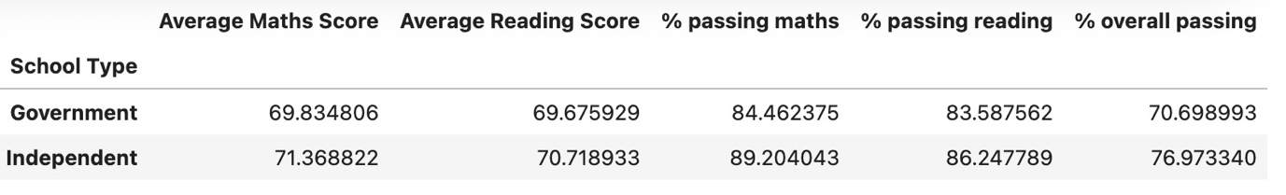

Independent schools show greater performance in both reading and maths scores. More actions should be taken to enhance government schools performance.